PROJECT DESIGN PHASE
PROPOSED SOLUTION
Date
Team ID | SWTID-2026-3317 _____
Project Name | AI FAQ Assistant
Maximum Marks | 2 Marks

Proposed Solution Template
The project team proposes an AI-powered FAQ Assistant to solve the problem of users spending time searching for frequently asked questions and support staff repeatedly answering common queries.
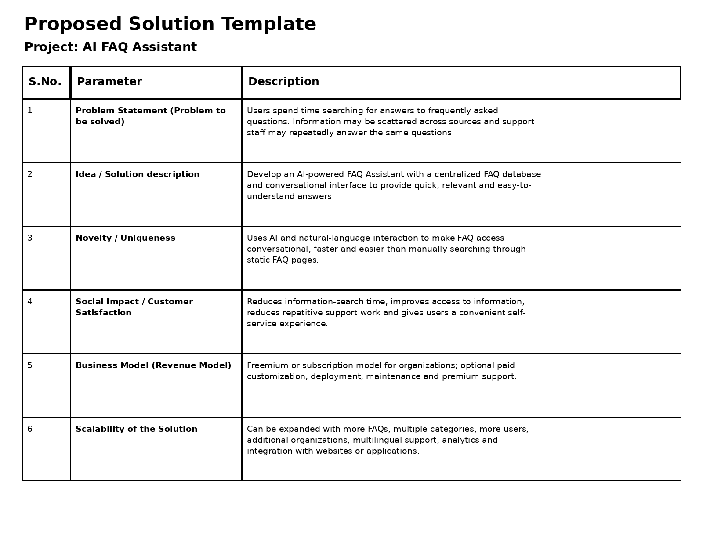

Completed Proposed Solution Template
S.No. | Parameter | Description
1 | Problem Statement (Problem to be solved) | Users spend time searching for answers to frequently asked questions. Information may be scattered across sources and support staff may repeatedly answer the same questions.
2 | Idea / Solution description | Develop an AI-powered FAQ Assistant with a centralized FAQ database and conversational interface to provide quick, relevant and easy-to-understand answers.
3 | Novelty / Uniqueness | Uses AI and natural-language interaction to make FAQ access conversational, faster and easier than manually searching through static FAQ pages.
4 | Social Impact / Customer Satisfaction | Reduces information-search time, improves access to information, reduces repetitive support work and gives users a convenient self-service experience.
5 | Business Model (Revenue Model) | Freemium or subscription model for organizations; optional paid customization, deployment, maintenance and premium support.
6 | Scalability of the Solution | Can be expanded with more FAQs, multiple categories, more users, additional organizations, multilingual support, analytics and integration with websites or applications.

Proposed Solution Summary: The AI FAQ Assistant provides a centralized and conversational way to access frequently asked questions. It is designed to save time, improve customer satisfaction, reduce repetitive support work and support future expansion.

